# NAME:MD.AFREEN

# ROLLNO:21MQ1A0519

RES ASSIGNMENT

Hydrogen energy refers to the use of hydrogen as a fuel source to generate energy. Hydrogen is the most abundant element in the universe, but it is rarely found in its pure form on Earth. It is commonly bound to other elements such as oxygen in water (H2O) or carbon in hydrocarbons.

Hydrogen has gained attention as a clean and versatile energy carrier because when it reacts with oxygen in a fuel cell or combustion process, it produces energy and releases only water vapor as a byproduct. This makes hydrogen a potentially environmentally friendly and sustainable alternative to traditional fossil fuels.

Here are some key aspects of hydrogen energy:

1. **Production Methods:**

- **Steam Methane Reforming (SMR):** This method involves extracting hydrogen from natural gas through a chemical process.

- **Electrolysis:** This method uses an electric current to split water into hydrogen and oxygen. If the electricity comes from renewable sources like wind or solar, the hydrogen produced is considered green.

2. **Storage and Transportation:**

- Hydrogen is a light and highly flammable gas, so its storage and transportation present challenges. Common methods include compressing it into tanks, liquefying it at low temperatures, or absorbing it into materials.

- There are ongoing efforts to develop advanced storage technologies to improve the safety and efficiency of hydrogen storage.

3. **Applications:**

- **Transportation:** Hydrogen can be used as a fuel for vehicles, either in internal combustion engines or in fuel cells that produce electricity to power electric motors.

- **Power Generation:** Hydrogen can be burned in conventional combustion engines or used in fuel cells to generate electricity for various applications.

- **Industrial Processes:** Hydrogen is used in various industrial processes, such as refining and chemical production.

4. **Environmental Impact:**

- Hydrogen is considered a clean energy carrier when produced using renewable energy sources because the only byproduct of its combustion or use in fuel cells is water vapor. However, the environmental benefits depend on the methods used for hydrogen production.

5. **Challenges:**

- **Cost:** Hydrogen production, especially green hydrogen, can be more expensive than conventional fossil fuels.

- **Infrastructure:** Building a widespread infrastructure for hydrogen production, storage, and distribution is a significant challenge.

Governments and industries are investing in research and development to address these challenges and promote the use of hydrogen as a clean and sustainable energy source. The hope is that hydrogen can play a crucial role in reducing greenhouse gas emissions and transitioning to a more sustainable energy future.

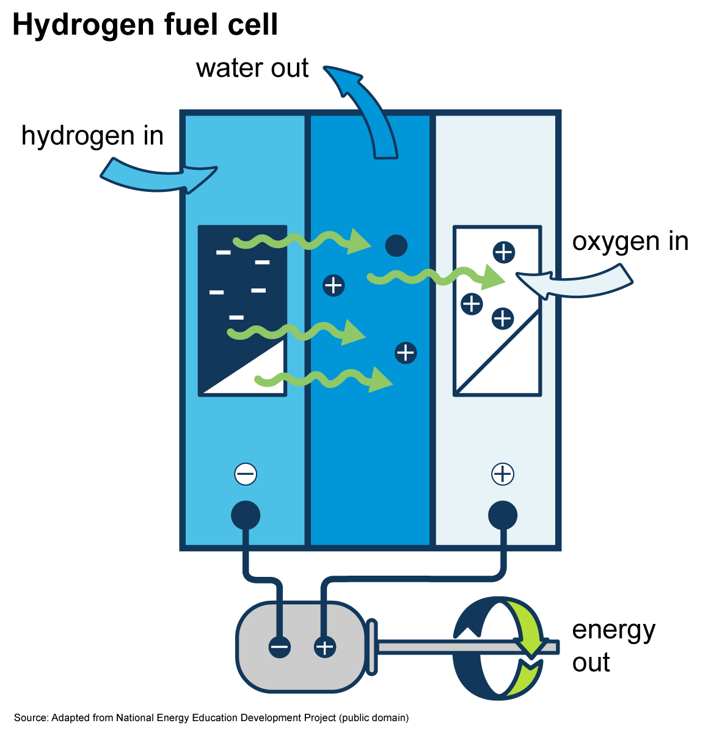

METHODS OF HYDROGEN PRODUCTION

Hydrogen can be produced through various methods, each with its own set of advantages and challenges. The primary methods of hydrogen production include:

1. **Steam Methane Reforming (SMR):**

- **Description:** SMR is the most common method for industrial hydrogen production. It involves reacting natural gas (methane, CH₄) with high-temperature steam to produce hydrogen and carbon monoxide.

- **Equation:** CH₄ + H₂O → CO + 3H₂

- **Byproducts:** Carbon monoxide is a byproduct, and the process emits carbon dioxide. SMR is not considered a "clean" method unless carbon capture and storage (CCS) technologies are implemented.

2. **Partial Oxidation:**

- **Description:** Partial oxidation involves reacting a hydrocarbon feedstock with a limited amount of oxygen or air. This produces hydrogen and carbon monoxide.

- **Equation:** CH₄ + 1/2O₂ → CO + 2H₂

- **Byproducts:** Like SMR, partial oxidation produces carbon monoxide and may require carbon capture for environmental sustainability.

3. **Electrolysis:**

- **Description:** Electrolysis involves using an electric current to split water (H₂O) into hydrogen (H₂) and oxygen (O₂).

- **Equation:** 2H₂O + electricity → 2H₂ + O₂

- **Types:**

- **A.** **Alkaline Electrolysis:** Uses an alkaline solution as an electrolyte.

- **B.** **Proton Exchange Membrane (PEM) Electrolysis:** Uses a solid polymer electrolyte membrane.

- **C.** **High-Temperature (Solid Oxide) Electrolysis:** Operates at elevated temperatures using a solid oxide electrolyte.

4. **Thermochemical Processes:**

- **Description:** Thermochemical methods use heat to drive chemical reactions that release hydrogen. This can involve processes like water-splitting, where water is decomposed into hydrogen and oxygen using high temperatures.

- **Example:** Sulfur-Iodine Cycle.

5. **Biological Production:**

- **Description:** Certain microorganisms, such as certain bacteria and algae, can produce hydrogen through biological processes like photosynthesis or fermentation.

- **Byproducts:** The byproducts depend on the specific biological process but can include organic compounds.

6. **Photoelectrochemical (PEC) Water Splitting:**

- **Description:** PEC involves using semiconductor materials exposed to light to drive the water-splitting reaction.

- **Byproducts:** Oxygen is produced as a byproduct.

7. **Photochemical Water Splitting:**

- **Description:** This method utilizes light-absorbing compounds to initiate a photochemical reaction that separates water into hydrogen and oxygen.

- **Byproducts:** Oxygen is produced as a byproduct.

8. **Hydrogen from Biomass:**

- **Description:** Biomass, such as agricultural or municipal waste, can be gasified to produce a hydrogen-rich gas.

- **Byproducts:** Gasification produces a mix of hydrogen, carbon monoxide, and other gases.

The choice of production method depends on factors such as cost, energy source availability, environmental impact, and the intended application of the hydrogen. Researchers are continually exploring and developing new methods to make hydrogen production more efficient, cost-effective, and environmentally friendly, with a focus on green hydrogen produced using renewable energy sources.

1. **Steam Methane Reforming (SMR):**

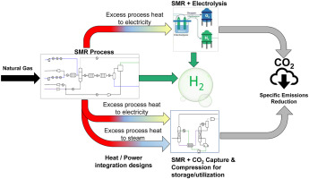

2.Partial Oxidation

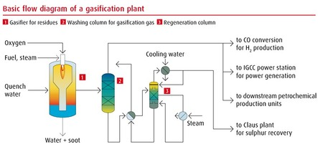

3.Electrolysis:

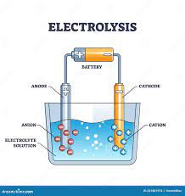

4.ThermoChemical Process:  
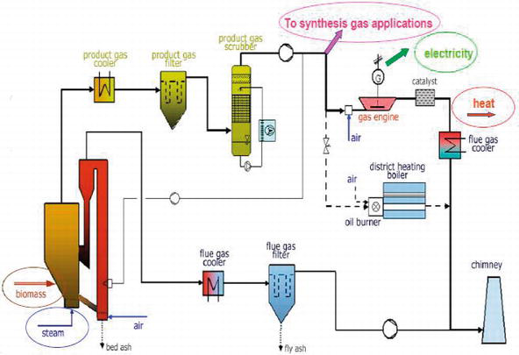

5.Biological Production

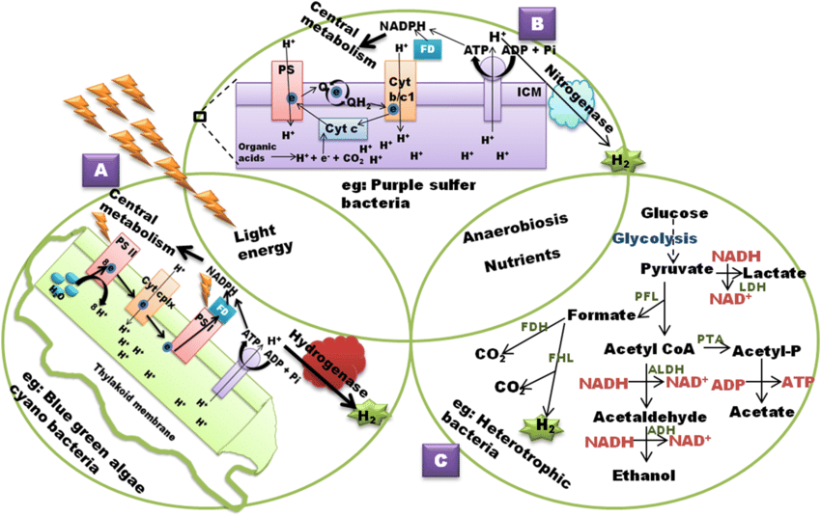

6.Photoelectrochemical water spilliting:

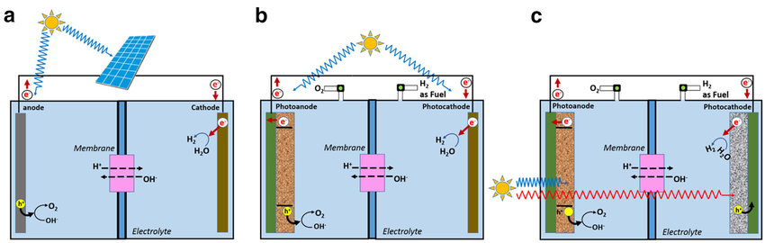

7.Photochemical Water spilliting:

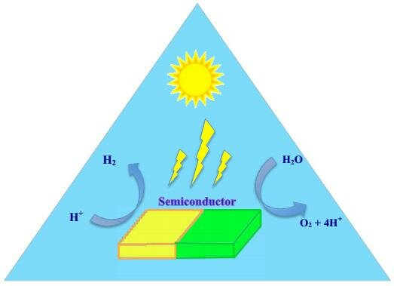

8.Hydrogrn from Biomass:

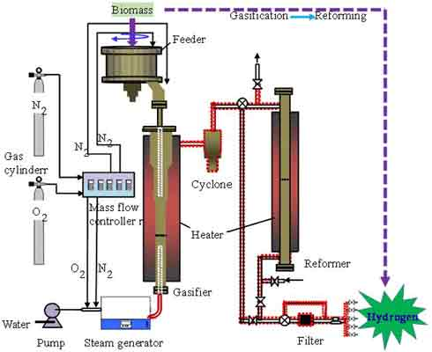

HYDROGEN ENERGY STORAGE

Hydrogen energy can be stored in various forms, and the choice of storage method depends on factors such as the intended use, efficiency, and safety considerations. The primary methods for storing hydrogen energy include:

1. **Gaseous Hydrogen Storage:**

- **Compressed Hydrogen (CH2):** Hydrogen gas is compressed at high pressures, typically between 350 and 700 bar (5,000 to 10,000 psi), and stored in high-strength tanks. The main challenge with this method is the energy required for compression and the weight and volume of the storage tanks.

- **Liquefied Hydrogen (LH2):** Hydrogen is cooled to extremely low temperatures (around -253°C or -423°F) to become a liquid. This process reduces the volume of hydrogen, making it more space-efficient for storage. However, liquefaction requires a significant amount of energy.

2. **Liquid Organic Hydrogen Carriers (LOHC):**

- Hydrogen can chemically bond with certain liquid organic compounds, creating stable and non-explosive liquid compounds. The hydrogen can be released when needed by applying heat or using a catalyst to break the chemical bonds. This method allows for safer and more compact storage.

3. **Hydride Storage:**

- Certain metal hydrides, such as magnesium hydride or sodium borohydride, can absorb and release hydrogen through reversible chemical reactions. Hydrogen is stored in the form of a solid compound, and releasing it involves heating or adding a catalyst. Hydride storage can offer moderate energy density and improved safety compared to some other methods.

4. **Carbon-based Materials:**

- Hydrogen can be adsorbed onto porous carbon materials, such as activated carbon or carbon nanotubes. While this method is still in the research stage, it has the potential for safe and reversible storage.

5. **Underground Storage:**

- Hydrogen can be injected and stored in geological formations, such as depleted gas fields or salt caverns. This method is similar to natural gas storage and takes advantage of the natural porosity of the rock formations.

Each storage method has its advantages and disadvantages, and the choice depends on factors like the specific application, cost, safety, and efficiency requirements. Researchers and engineers are actively working to improve existing storage technologies and develop new, more efficient methods for storing hydrogen energy.

1. Gaseous Hydrogen Storage:

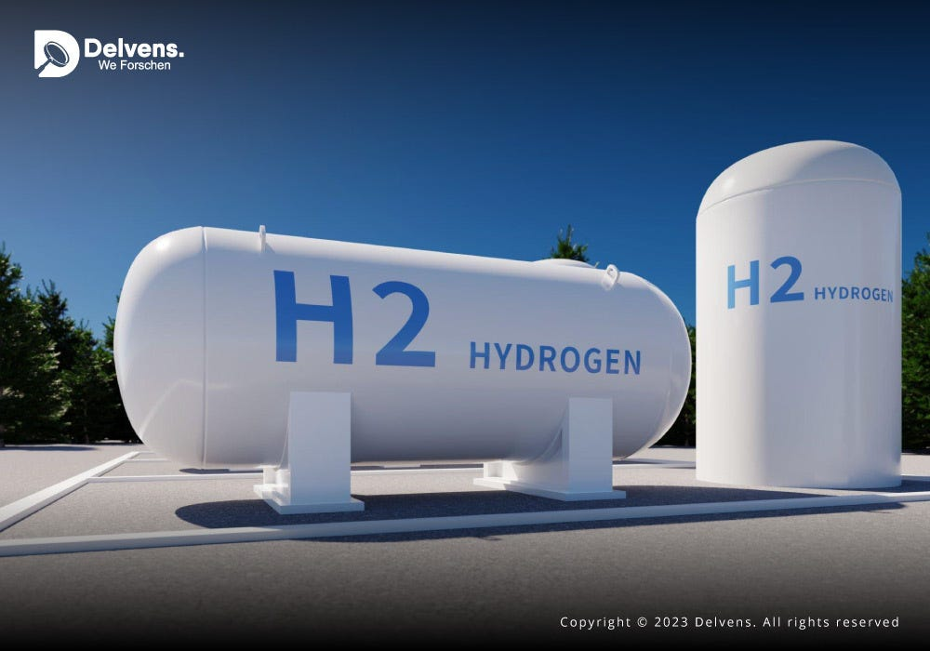

2. **Liquid Organic Hydrogen Carriers (LOHC):**

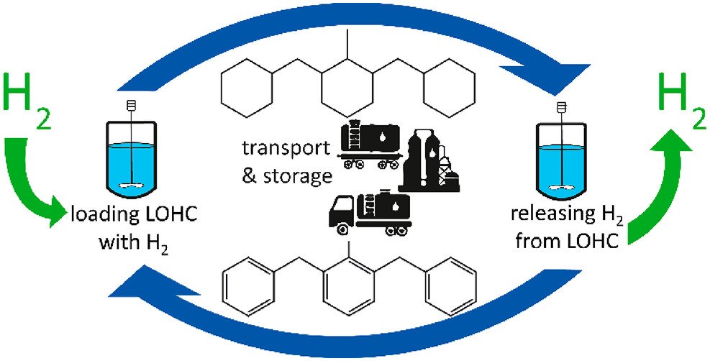

3. **Hydride Storage:**

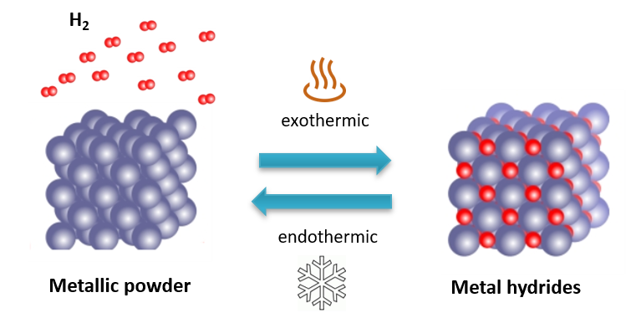

4. **Carbon-based Materials:**

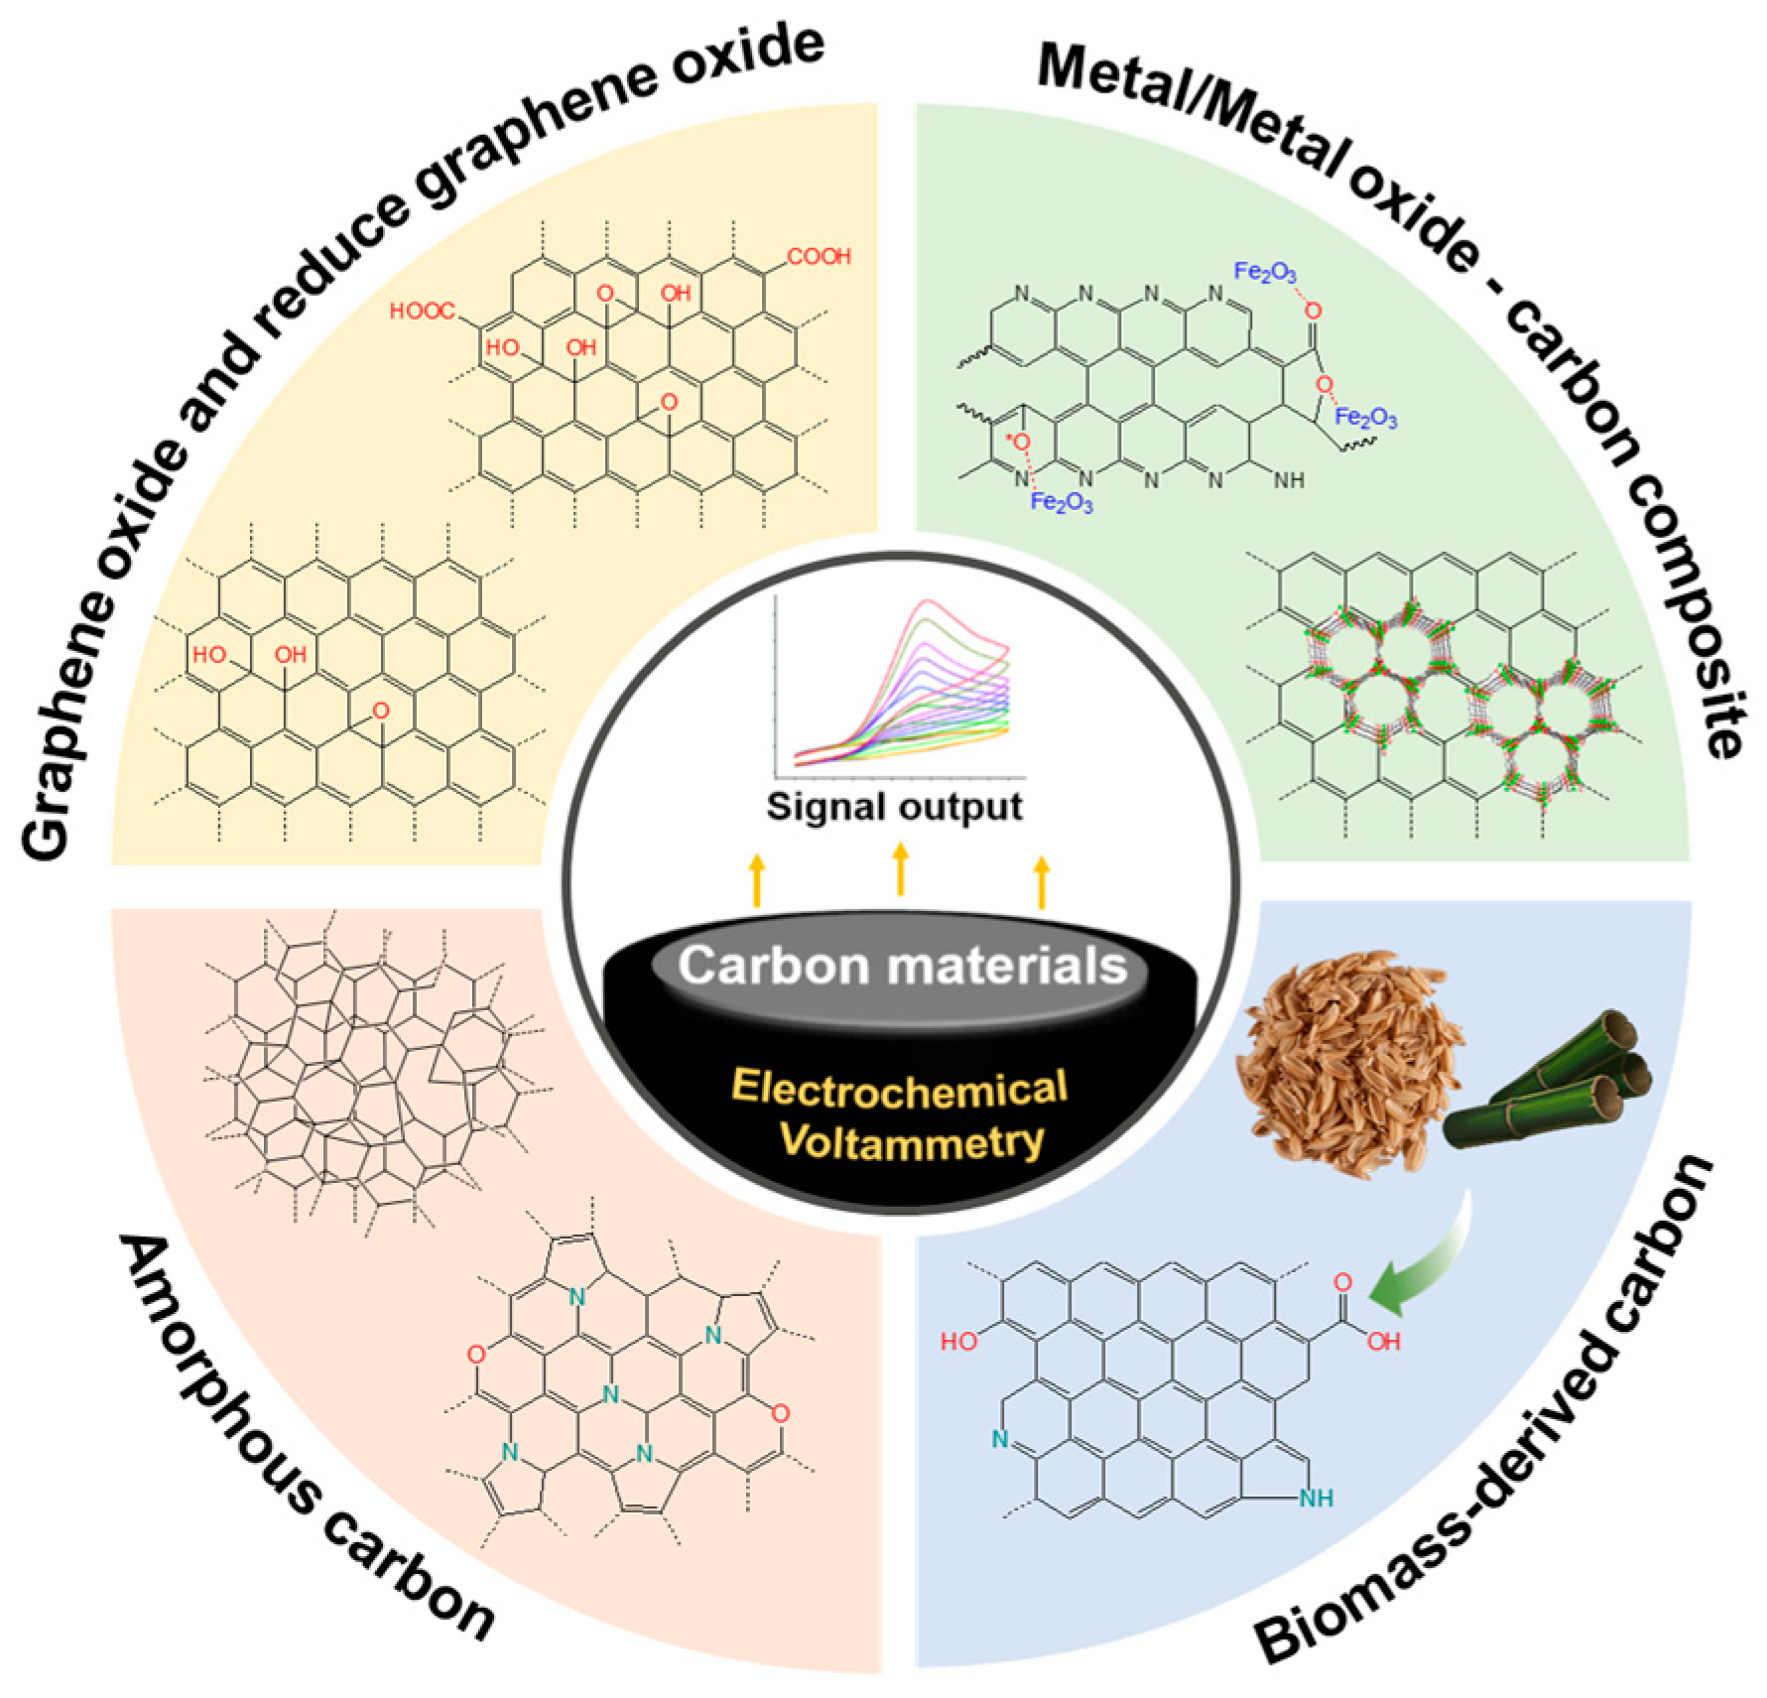

5. **Underground Storage:**

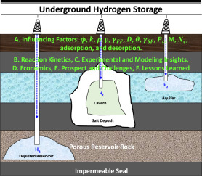

APPLICATIONS OF HYDROGEN STORAGE

Hydrogen energy has various applications across different sectors, and its versatility makes it a promising candidate for a clean and sustainable energy carrier. Some key applications of hydrogen energy include:

1. **Transportation:**

- **Fuel Cell Vehicles (FCVs):** Hydrogen fuel cells can power vehicles by converting hydrogen gas and oxygen from the air into electricity, with water as the only byproduct. FCVs offer a zero-emission alternative to traditional internal combustion engine vehicles.

- **Hydrogen-Powered Trucks and Buses:** Hydrogen fuel cells can also be used to power larger vehicles, such as trucks and buses, providing a solution for heavy-duty transportation.

2. **Power Generation:**

- **Stationary Fuel Cells:** Hydrogen fuel cells can be used for stationary power generation in buildings, data centers, and remote areas. They offer a reliable and efficient source of electricity with low emissions.

- **Hydrogen Combustion:** Hydrogen can be burned directly in a combustion engine to generate heat and electricity. While this process produces water vapor as the only emission, it may not be as efficient as fuel cells in converting hydrogen to electricity.

3. **Industry:**

- **Hydrogen as a Feedstock:** Hydrogen is a crucial feedstock for various industrial processes, including the production of ammonia (used in fertilizers), refining of petroleum, and the manufacturing of chemicals such as methanol.

- **Heat for Industrial Processes:** Hydrogen can be used as a clean fuel for high-temperature industrial processes, such as steel and glass manufacturing.

4. Energy Storage:

- Grid Balancing:Hydrogen can be used as a form of energy storage to balance intermittent renewable energy sources like wind and solar. Excess electricity generated during periods of high renewable energy production can be used to produce hydrogen through electrolysis, and the hydrogen can later be converted back to electricity when needed.

5. **Residential and Commercial Heating:

- **Hydrogen for Heating:** Hydrogen can be used as a clean source of heat for residential and commercial buildings, either directly or through fuel cells that produce both heat and electricity.

6. **Maritime Applications:**

- **Hydrogen-Powered Ships:** Hydrogen fuel cells can provide an alternative power source for ships, reducing emissions in the maritime industry.

7. **Aerospace:**

- **Hydrogen-Powered Aircraft:** There is ongoing research into the use of hydrogen as a fuel for aircraft, aiming to reduce emissions in the aviation sector.

These applications demonstrate the potential of hydrogen as a versatile and sustainable energy carrier that can contribute to decarbonizing various sectors of the economy. As technology advances and the hydrogen infrastructure develops, the range of applications is expected to expand further.